

OPERATING MANUAL - ELECTRIC SMOKER WITH IN-HOME SMOKE GENERATOR


BBDST-70 • BBDST-150 • UWDT-70 • UWDT-150

Table of contents:
- Safety requirements and precautions
- What’s included
- Technical parameters
- Design and operation description
- Assembly and installation
- How to use the electronic control panel
- First start-up / first smoking
- How to care for your smoker
- Troubleshooting

 | Address : ul. Aleja Niepodległości 41, 78-449 Borne Sulinowo, Poland |  |  | 
NIP PL 8992343025 | PHONE (+48) 94 373 00 02 | info@borniak.com | www.borniak.com

- Safety requirements and precautions.


Please review the following notes and instructions.
Doing so will help you operate your device safely and conveniently.
Thank you,
The Borniak Team.


  - The device is factory-set to operate on single-phase AC power (230V 1N~50 Hz).
Warning: Electricity
  - The device is equipped with a connecting cable with a cross-section of 3x1.5 mm² and a length of approximately 2 m, terminated with a plug featuring a protective contact.
  - The electrical outlet must be equipped with a protective pin. Once the device has been set up, the user must have access to the electrical outlet.
  - Check the following before connecting the device to the outlet:
- the fuse and electrical installation must withstand the load of the device,
- the power supply circuit of the plug-in socket must be protected with a min. 16A fuse,
- the electrical installation must be equipped with an effective grounding system that meets the requirements of current standards and regulations,
- the electrical outlet to which the device will be connected must be protected by a residual current circuit breaker with Ir ≤ 30mA.
  - If the power supply cord or plug is damaged, replace it immediately to avoid a hazard.
  - If you are using an extension cord, make sure that it has a current load capacity that is at least equal to the rated load of the device, an effective protective contact (grounding), that it is suitable for outdoor use and labeled as 'for outdoor use,' and that it is fully unwound.
  - The power supply cords should be arranged in such a way that they are not pinched, do not pose a risk of accidental pulling or tripping, especially by children, and do not come into contact with hot parts of the device at any point.
  - Risk of electric shock. Keep the connector of the extension cord in a dry place, making sure it does not touch the ground, and do not immerse the cord or plugs in water or other liquids.
  - The smoke generator must not be connected to the power supply until it has been installed with a device adapted for connecting a smoke generator.
  - Disconnect the device from the power outlet when not in use and before cleaning.
  - In the event of a breakdown or improper operation of the device, disconnect it from the power supply.

Precautions

  - Do not allow the device to be flooded with water (for example during washing or if the device is left outdoors uncovered during precipitation).
  - The smoke generator may only be used with smoking cabinets recommended by the manufacturer.
  - The use of accessories not recommended by the manufacturer may result in damage to the device, for which the manufacturer will not assume responsibility.

  - Exercise extreme caution when dealing with sharp edges during assembly, disassembly and use of the device. Do not use the device for purposes other than those intended.
  - The device is intended for home use only.
  - Do not leave the device turned on once the smoking process is finished.
  - The device should be inaccessible to house pets.
  - Do not allow children to use the device without strict adult supervision.
  - This device is not intended for use by persons (including children) with reduced physical, sensory or mental abilities or without appropriate knowledge and experience, unless they are supervised or have been instructed on its safe use.
  - Children should not have free access to the device.
  - The device requires strict supervision during use.
  - Do not modify the device from its original state.

Caution: location

  - The power cables of the device must be arranged so that they do not come into contact with hot parts of the housing.
  - The device is designed for outdoor use, but must not be exposed to precipitation or strong winds. The optimal solution is to use the device in covered, sheltered and well-ventilated areas.
  - Do not use the device indoors. When used under a roof, adequate ventilation must be provided.
  - Do not use the device in the proximity of petrol, other flammable liquids, gases, or in places where flammable vapors may be present.
  - Do not use the device near flammable objects.
  - Do not use the device in contact with objects made of materials that are not resistant to high temperatures.
  - We recommend keeping a fire extinguisher in the vicinity of the device. For information on the appropriate size and type of fire extinguisher, contact your local authorities or the fire department.
  - Do not connect the device to the power outlet until it is fully assembled.
  - Do not move the device without first removing all moving parts inside the smoker, as well as the smoke generator.
  - Do not connect the device to a chimney, vent or other ductwork that may cause forced air circulation.
  - Do not place the device in direct contact with a wall. A minimum distance of 30 cm should be maintained.

Caution: temperature

  - Parts of the device may become very hot during use. There is a risk of burns if the device is handled carelessly.
  - Do not touch hot surfaces. Use appropriate protective gloves resistant to high temperatures (for example, in accordance with DIN EN 407).

I. Safety requirements and precautions.

  - Children and house pets should not approach the device without supervision as there is a risk of burns.
  - Wait for the device to cool down completely before cleaning.
  - Do not use petrol, kerosene, alcohol or other flammable substances to clean the device.

Usage guidelines

  - Do not use the smoker as an oven – avoid maintaining high temperatures for extended periods.
  - Do not leave the device unattended while operating.
  - Do not exceed the maximum permissible operating temperature of the device.
  - Do not use the device with damaged electrical cords.
  - Do not use the smoker during rain, strong wind or storms.
  - Do not place the device near flammable substances.
  - Avoid wearing loose clothing and tie back long hair when using the device.
  - Do not move the device while it is operating.
  - Do not use the device indoors – the device is intended for outdoor use only.
  - Do not place the device in places accessible to children and house pets.
  - Do not touch hot parts of the device, as there is a risk of burns. We recommend the use of appropriate protective gloves resistant to high temperatures (for example, in accordance with DIN EN 407).
  - Do not use the packaging to cover the device.
  - Connect the device to a grounded electrical outlet or grounded extension cord only.
  - Protect the device from rain and water exposure.
  - Unplug the device after each use.
  - Clean the smoker thoroughly after each use.
  - Do not cover the device or place any objects on it while it is operating.
  - Empty the ash and grease tray every 2 to 3 hours and fill it with fresh water.
  - The electrical outlet to which the device will be connected must be protected by a residual current circuit breaker with Ir ≤ 30 mA.
  - Do not place the device directly against a wall – keep a minimum distance of 30 cm.
  - When smoking fatty foods (and when there is a risk of fat rendering), the drip tray should be properly secured to prevent fat from dripping onto it. We recommend using an additional metal tray to collect fat. The tray for collecting fat should be placed at least on the second shelf from the bottom.

  - Do not cover the temperature sensor to make sure the device can properly monitor operating conditions.

  - Do not place products in a way that obstructs the free flow of air, as this may interfere with device operation.

- What’s included
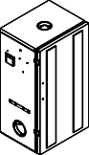
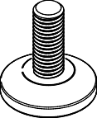
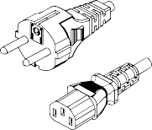
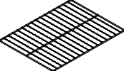
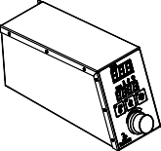

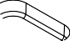

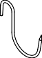
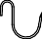
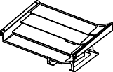

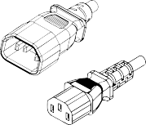

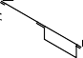
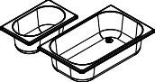


The illustrations do not reflect the actual dimensions of the parts:
* the type of plug depends on the country of distribution
** type and quantity depends on the model
UWDT/BBDST Smoker
1
2
3
4
- Smoking cabinet
- Control panel
- Drip tray
- Condenser
5
6
7
8
- Adjustable feet 4 pcs.
- Door handle + screws 2 pcs.
- Carrying handles 2 pcs.
- Water and fat container
9
10
11
12
- Power cable EU* - C13
- GN ½ tray (BB version only)
- Crossbar for hanging 3 pcs.
- Chimney with damper
13
14
15
16
- Smoking shelf**
- Smoking hooks**
- Power cable C12-C13
- Smoking wood chips 3x2L

GD-01/GDS-01 Smoke Generator
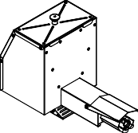  1 | 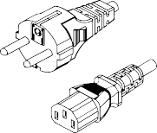  2 | 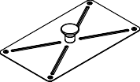  3 | 4 | - Smoke generator  - Power cable EU* - C13  - Generator cover  - Smoking wood chips 2x2L

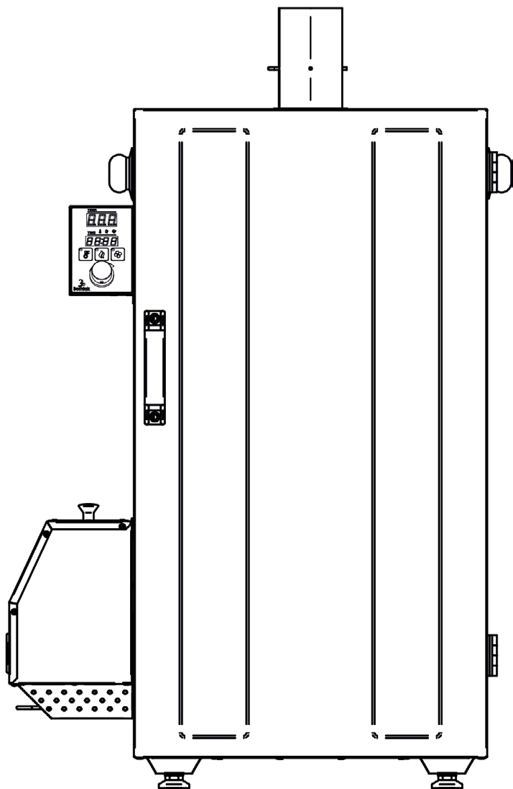
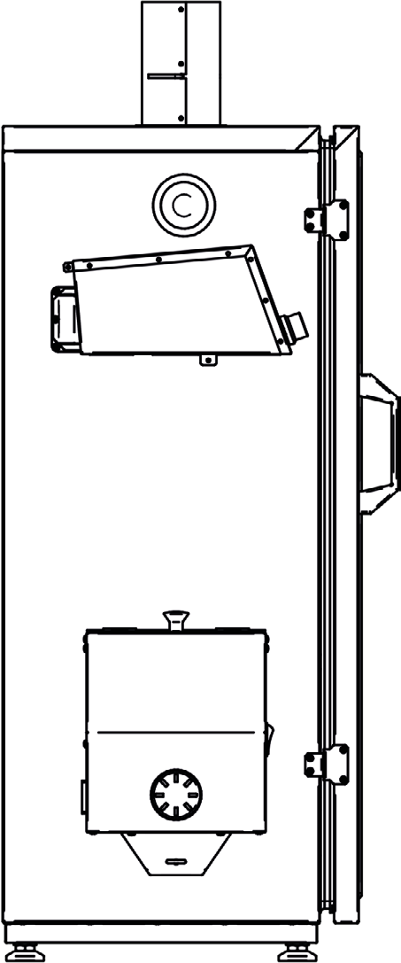
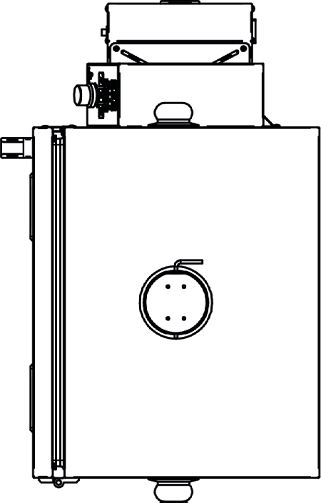
- Technical parameters
* TYPE 70
**TYPE 150
630* 720**
360* (480**)
400* (520**)
440* (530**)
970* (1135**)
825*(990**)

TECHNICAL PARAMETERS: SMOKER, SMOKE GENERATOR AND CABINETS
MODEL/TYPE | UWDT-70 | BBDST-70 | UWDT-150 | BBDST-150 | GD-01, GDS-01
RATED VOLTAGE | 230 V | 230 V | 230 V | 230 V | 230 V
POWER | 615 W | 1115 W | 1515 W | 2015 W | 115 W
CHAMBER HEATER POWER | 500 W | 1000 W | 1400 W | 1900 W | 110 W
FUSE | 8A (1.25A) | 10A (1.25A) | 8A (1.25A) | 10A (1.25A) | 1.25 A
CHAMBER CAPACITY | 70 L | 70 L | 150 L | 150 L | 2L
MAXIMUM TEMPERATURE | 120°C | 150°C | 120°C | 150°C | -
HOUSING INGRESS PROTECTION RATING | IP20
EXTERNAL DIMENSIONS
WIDTH [mm] | 630 |  | 720 |  | 360
DEPTH [mm] | 400 |  | 520 |  | 180
HEIGHT [mm] | 970 |  | 1135 |  | 250
USABLE INTERNAL DIMENSIONS
WIDTH [mm] | 395 |  | 485 |  | -
DEPTH [mm] | 300 |  | 420 |  | -
HEIGHT [mm] | 605 |  | 740 |  | -

- Design and operation description

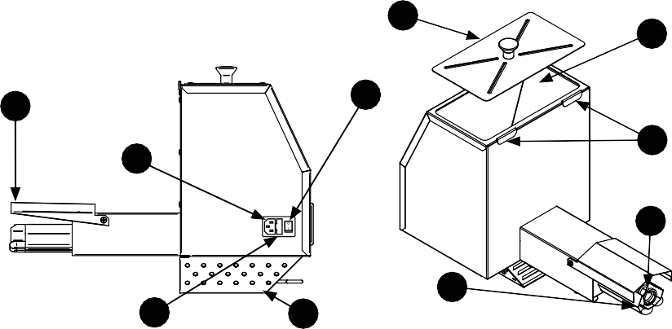
GD-01/GDS-01 Smoke Generator
 |  |  |  |  | 1
 |  |  |  |  |  |  | 2 | 1. Cover
 |  |  |  |  |  |  |  | 2. Container
9 |  |  |  | 3 |  |  |  | - Switch  - Fuse
 | 5 |  |  |  |  |  | 8 | - Power cord  - Heating element
 |  |  |  |  |  |  |  | 7. Wood chip feeder
 |  |  |  |  |  |  | 7 | 8. Hooks
 |  |  |  |  |  |  |  | 9. Heating element cover
 |  |  |  |  |  | 6 |  | 10. Air access shutter
 |  | 4 | 10

▶ After the smoke generator is started, the wood chip feeder (7) starts to rotate and the heating element (6) starts to heat up. The feeder continuously transports the chips from the container (2) to the surface of the heating element.
▶ The feeder continuously transports the chips from the container (2) to the surface of the heating element, where they start to smolder because of the temperature, producing smoke.
▶ The smoldering chips are moved along the heating element (6) and fall into a container with water, which prevents further burning and ensures safety.

Smoking cabinet
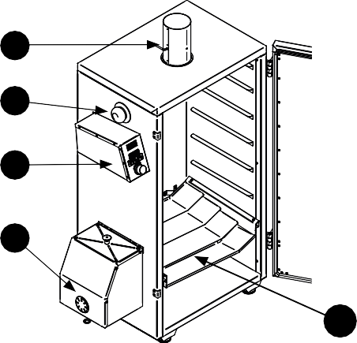  1 |  | - Exhaust chimney with damper  - Carrying handle | 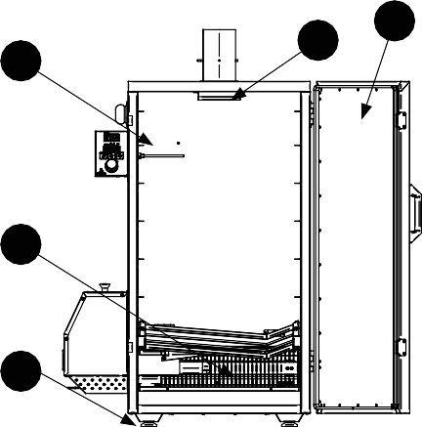  6 | 8 | 5
2 |  | - Electronic control panel  - Drip tray
 |  | 5. Doors with magnetic closure
3 |  | - Temperature measurement probe  - Heating element | 7
10 |  | - Condenser  - Adjustable feet
 |  | 10. Smoke generator | 9
 | 4

Description of the operation of the smoker with smoke generator: The smoker operates on the principle of controlled smoke production and maintaining the appropriate temperature, both of which are crucial in the smoking process. Here's how the individual components of the device work together:

The smoke generator (10) produces steady smoke, which is essential for proper smoking of your products. The chimney with damper (1) on top of the smoker allows you to regulate the smoke density in the chamber and adapt it to the type of smoked products. The heating element with radiator (7) maintains the temperature you need in the chamber. Simply select the desired temperature on the control panel (3) and the heating element automatically adjusts it. The condenser (8) helps prevent smoke condensation from dripping onto your products.
The drip tray (4) protects the heating element and generator from juices and fat coming from smoked foods.

When smoking fatty foods (and when there is a risk of fat rendering), the drip tray should be properly secured to prevent fat from dripping onto it. We recommend using an additional metal tray to collect fat. The tray for collecting fat should be placed at least on the second shelf from the bottom.

There are two trays in the device: one for extinguishing falling chips and a second for collecting fat from smoked products. The smoker uses approximately 250 ml of smoking wood chips per hour. A single load of the generator (approximately 2 liters of wood chips) is sufficient for 6-8 hours of smoking.

All these elements guarantee precise and efficient smoking, ensuring excellent results with minimal user effort.

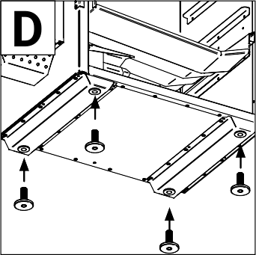
- Assembly and installation
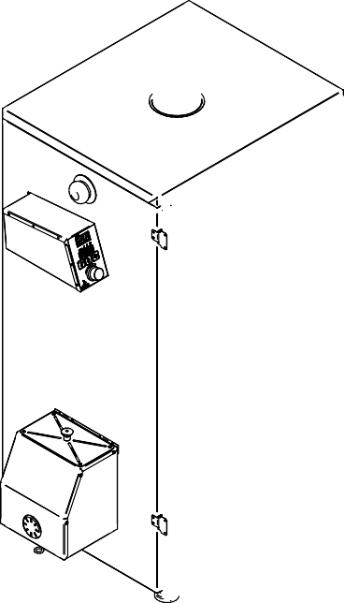
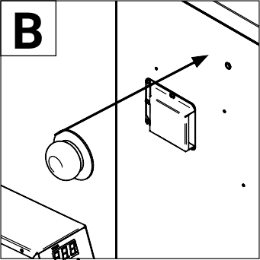
A




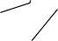


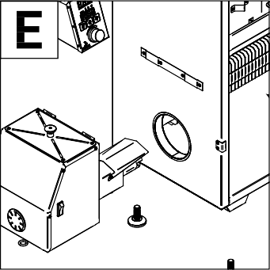
A Remove the device from the box, discard any unnecessary packaging and read the user manual. B Attach the carrying handles. C Attach the door handle. D Set the device in the appropriate location, tilt it slightly, screw the feet into the sockets on the bottom and adjust them to ensure that the device is level and upright. E Insert the smoke generator heating element into the hole on the left wall. Tilt the generator slightly to attach it to the hooks. F Insert the chimney into the opening on top of the smoker, making sure that the damper is not completely closed to ensure proper air exchange in the chamber. We recommend keeping the maximum damper closure at no more than 70% of the air flow. G Slide the condenser under the chimney.
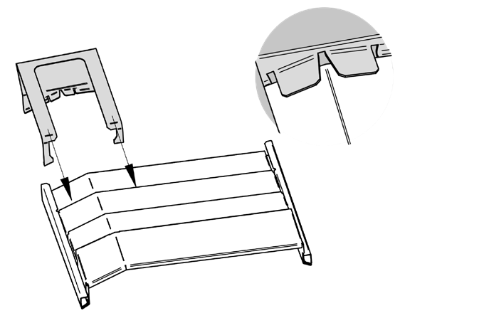
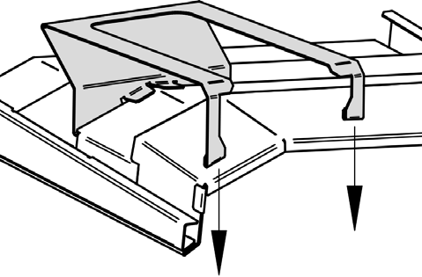
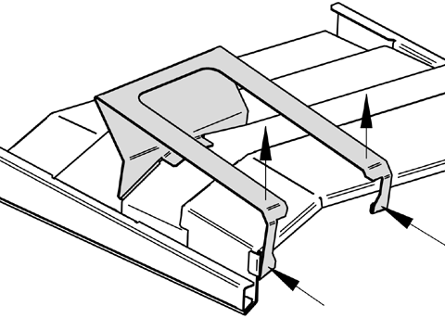
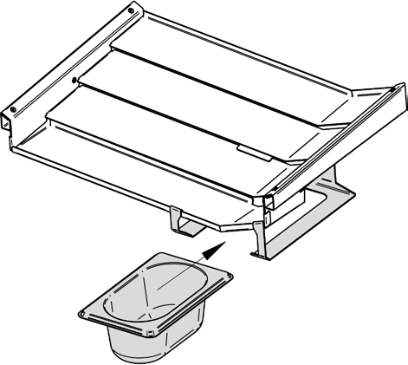
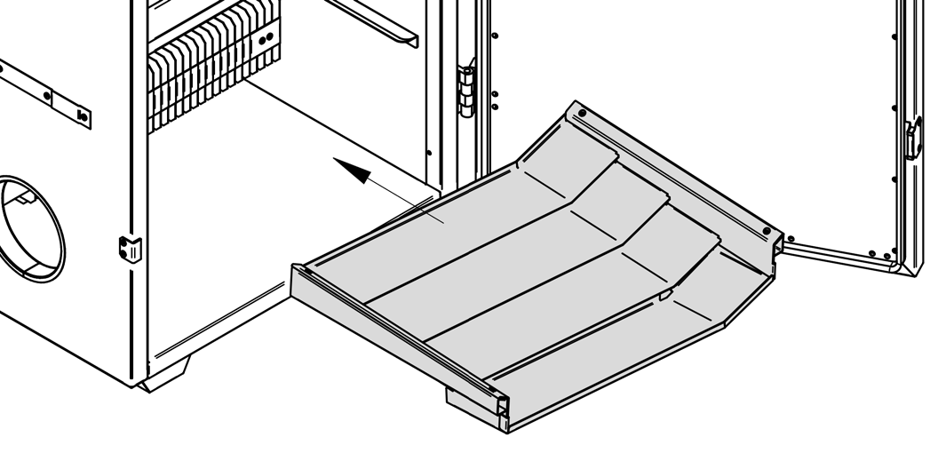
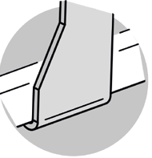
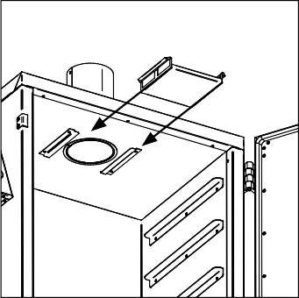
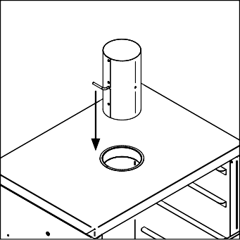

h1
h2
h3
h4

H Install the drip tray holder before inserting the drip tray. To do so, turn the tray over and insert the hooks as shown in figure h1. Then attach the handle onto the edge of the tray as shown in figure h2 and h3. Turn the tray back over, place it in the smoker and insert the tray as shown in figure h4.

V. Assembly and installation
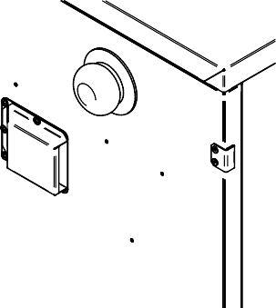
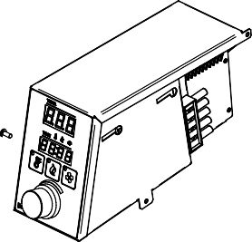

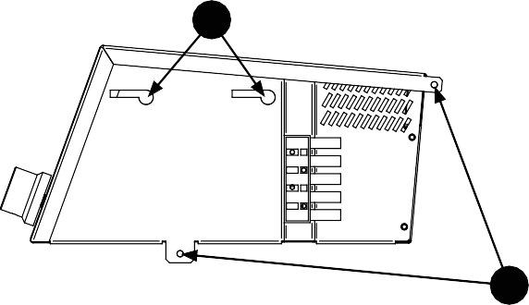
B
A
A
B
A
B

I Loosen the screws (point B) from the smoker housing. Mount the electronic panel so that the holes in the panel align with the screws (point A). Slide the panel toward the back wall of the smoker until the connectors on the panel and smoker connect. Insert and tighten the screws in the correct locations (point B).

VI. How to use the electronic control panel

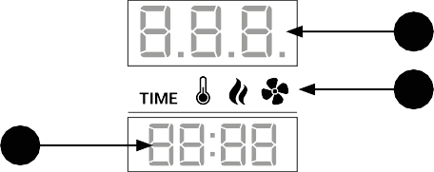




Control panel
1  2 | 3  4 | - Time controller display  - Function buttons  - Temperature controller display  - Indicator LEDs for the display (1)  - Temperature setting knob  - Dehydrator power socket  - Smoke generator power socket  - Main switch  - Fuse  - Connector - connection to the chamber  - Power socket - connection to power supply | 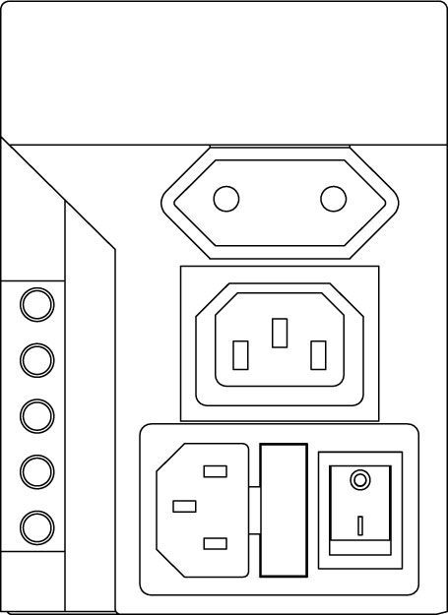        10 | 6  7  8
 |  |  |  | 9
 | 5 |  | 11

Connection:

Before proceeding with the connection, make sure the device is disconnected from the power source. First, mount the panel on the cabinet using socket (10), according to the instructions in the "Assembly and installation" chapter. If you are using a dehydrator (optional accessory, not included with the device), connect it to the dehydrator power socket (6). Connect the smoke generator to the generator power socket (7), and connect the main power cable to socket (11). Make sure all plugs are inserted properly to avoid damage to the device or improper operation.

CHANGING THE SET TEMPERATURE.


Press the knob
PRESS
SET

Set the desired temperature
Press again
PRESS

How to use the electronic control panel

To set the time for a given function, press the appropriate button* and hold for 2 sec
On the display (1) the first two fields for setting the hour will start flashing. Turn the knob (5) to set the appropriate value and confirm by pressing the knob.
The next two fields for setting the minutes will start flashing on the display. Turn the knob (5) to set the appropriate value and confirm by pressing the knob.
The timer will start* and the time for a given function will count down, the indicator will start flashing. Once the countdown has finished, the function will automatically turn off.


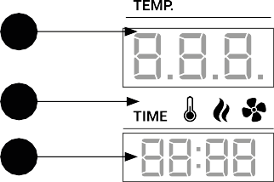




Setting the time:
3

4

1

2
5
Setting the time
The highlighted symbol (4) indicates the currently selected function for which the time is displayed (1). By turning the knob (5), you can change the highlighted symbol (4) and the function time displayed.

Turning off the time:
Follow the instructions to set the time. Set the value to 00:00

You can set the operating time for each of the three functions, i.e. heating, smoke generator or dehydrator. If the time has not been set, the display (1) indicates how much time has passed since the function was enabled. The electronic temperature controller reaches the set temperature by cyclically turning the heating element in the smoker on and off, which helps maintain a constant, set temperature.



Activating the dehydrator (optional): Before activating, make sure the dehydrator is properly connected to the smoker according to the instructions. (Remember: the dehydrator cannot be connected to the cabinet at the same time as the smoke generator!). Start the control panel using the switch (8). Press on the control panel. The light on the button will turn on, indicating that the dehydrator has been activated.
Note: when the dehydrator is activated, the smoke generator will be turned off.
Activating the smoke generator: Before activating, make sure that the smoke generator is positioned correctly according to the instructions in the "Assembly and Installation" section. Make sure the power button on the smoke generator is turned on. Then start the control panel using the switch (8). Press on the control panel. The light on the button will turn on, indicating that the smoke generator has been activated.

Short press - turns the function on/off
Long press 2 sec - sets the time
Indicator is on - function is on.
Indicator flashes - function activated with timer

DESCRIPTION OF FUNCTION BUTTONS

Activating the heating: Start the control panel using the switch (8), press on the control panel. The indicator will come on and the heating function will be activated.

- First start-up
Preheating

  - Fill the larger tray halfway with water and place it under the generator heating element. Make sure the fat drip pan is properly seated in the drip tray. Place the smoking wood chips included with the device into the generator container. Set the chimney damper at a 45 degree angle.

The first smoke will begin to emerge approximately 5 minutes after the process begins.
Use of the smoker does not require any special skills, allowing you to achieve excellent smoking results with minimal effort.

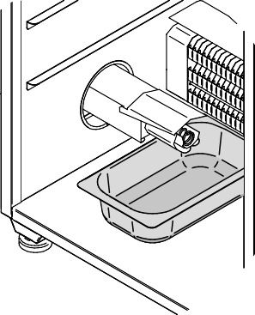
  - Connect the generator and smoker to a 230V power network with protective grounding. Turn on the smoke generator and the smoking cabinet. On the electronic panel, set the temperature to approximately 80°C (see: How to use the electronic control panel).
  - Preheat the smoker for approximately 2 hours. Doing so removes technological odors and creates initial seasoning of the device. Once the preheating process is complete, you can begin the actual smoking.
    - The device cannot reach a temperature lower than the ambient temperature in the chamber.

    - If you are not using the cold smoke adapter, the temperature in the chamber may rise to 70°C depending on the smoker model and weather conditions. This is due to the fact that by burning the smoking wood chips, the smoke generator produces heat, which in turn increases the temperature inside the device.

    - Before the desired temperature is reached, the heating process slows down to avoid exceeding the set value. It may take some time for the device to reach the target temperature.

    - The smoke generator container should only be filled with smoking wood chips recommended by the device manufacturer.

    - The tray for burnt chips should be cleaned and refilled with water every 2-4 hours.

First smoking

General method for smoking meat and fish:

High temperatures may cause fat to render.
Use an additional tray (do not place it on the separator tray) to prevent excess fat from dripping onto the separator tray.

- Pour water into the tray for burnt chips. Set the chimney damper at a 45 degree angle.
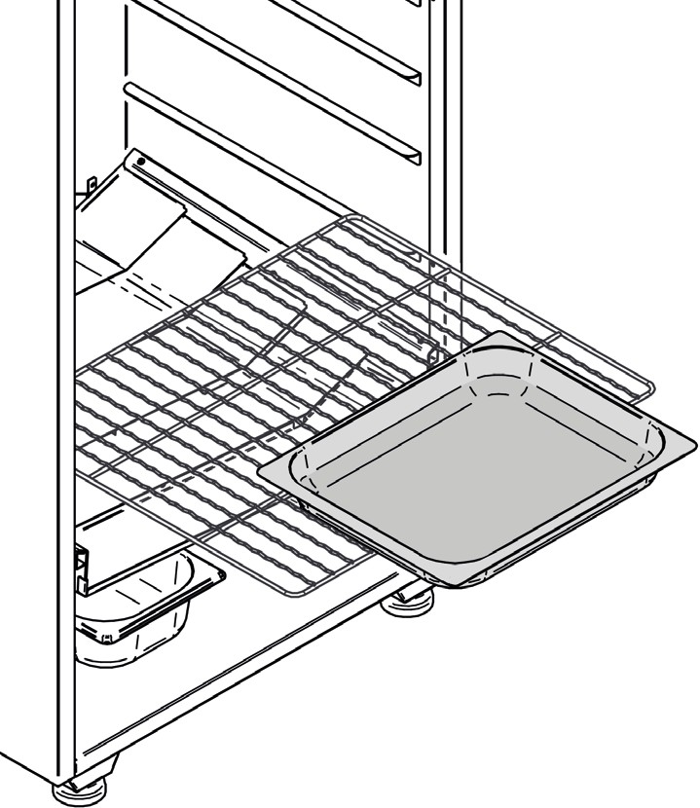
- Preheat the smoker to 60°C and once the desired temperature is reached, place the products in the smoker. Make sure there are wood chips in the smoke generator container, then turn on the smoke generator.
- Smoke for 2-3 hours, then increase the temperature to 90°C and continue smoking until the products reach the correct internal temperature.

Remember:

Any product you intend to smoke must be dry. Wet or insufficiently dried meats may release excess moisture, which can result in a bitter taste and unsightly streaks on the products. The drier the products, the shorter the smoking time.

The time needed to reach the appropriate temperature inside the products depends on their size. The larger the cross-section, the longer the smoking time. For fish and sausages you need approximately 1 hour, for tenderloins 1-2 hours, and for ham 3-4 hours.
Correct positioning of the tray is shown in the figure above.
Visit our website for detailed recipes and smoking methods.

How to care for your smoker
Notes

cloth or sponge. Avoid coarse metal brushes that may scratch the surface. After cleaning the surface, we recommend

- Before you start cleaning, make sure the cabinet is disconnected from the power supply.
- When cleaning the inside of the smoker, take special care when handling thin elements to avoid cuts.
- Do not use products containing chlorine, bleach, or strong acids or alkalis for cleaning. Before using a product, test it in an inconspicuous place.
- Do not use a high pressure washer as this may damage the electric heating element in the smoking chamber.
the use of a care product for polished stainless steel surfaces. Such products close fine pores with a thin, anti-static protective layer and give the surface a nice shine.

Cleaning the housing – aluzinc steel


Note:

- Do not use scouring powders, nitro solvents, chlorine solutions, aromatic cleaning agents or agents containing ammonium chloride or sodium salts.
- Heavy scrubbing can cause damage to the sheet metal coating.

If there are any deposits of grease or dirt on the housing, clean it

The common belief that after smoking fish you cannot prepare other products in the same smoker is incorrect. The aroma of one product does not influence the taste or smell of another.

with a mixture of water and dish soap, using a soft cloth or

Cleaning the accessories
sponge. Avoid coarse metal brushes that may scratch the surface. For heavier stains, use a mild detergent for aluminum and galvanized surfaces. Always test the cleaner in an inconspicuous area to make sure it is safe for the surface you are cleaning.

Elements such as the drip tray, condenser, trays, crossbars, grates

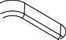



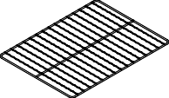
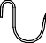
or hooks are dishwasher safe.

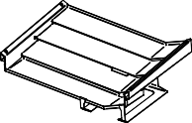

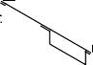
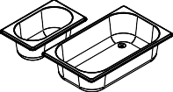

Cleaning the inside

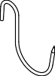
Clean the smoker using a stainless steel cleaner or a mixture of water and dish soap with a rough cloth or sponge. Avoid metal brushes that may scratch the surface. After cleaning, rinse with water and dry with a cloth.

Cleaning the housing – stainless steel

If there are any deposits of grease or dirt on the housing, clean the smoker using a stainless steel cleaner or a mixture of water and dish soap. The steel surface should be cleaned with a rough

Cleaning the smoke generator

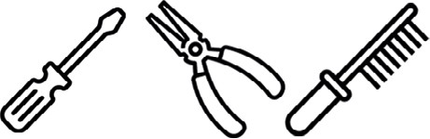
During operation of the device, smoke deposits form on parts of the chip, which must be cleaned and removed after every 6-8 hours of generator operation. Use pliers, a wire brush, or another blunt instrument for this purpose.
Failure to remove smoke deposits may result in improper operation of the device and even damage in the worst case scenario.

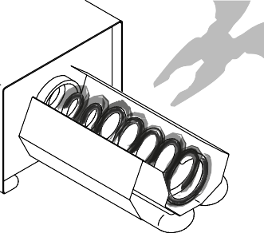

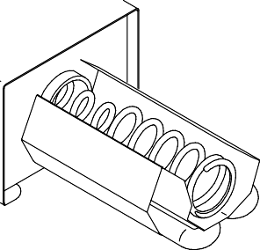

Troubleshooting



The temperature first heats the chamber to a certain value, drops by approximately 30°C and then increases again.
Smoking cabinet:

Possible causes and solutions:

The smoker is not heating.

Possible causes and solutions:

Check the set temperature
To set the desired temperature, press the knob, set the appropriate value, then press the knob again to confirm.
Timer panel: Press the temperature button – the LED next to the button should illuminate or flash to indicate that the heat setting has been activated. Damaged heating element
When the heating element is in operation, the dot in the lower right corner of the temperature display should light up or flash. It indicates that the heating element is working. If the light is on and the heating is not heating, contact your dealer or service center.

If the control panel is working properly but the smoker is not heating. Please contact your dealer or service center. A damaged heating element may be the reason.
- Damaged thermal switch
If this is the case, contact your dealer or service center to diagnose and repair the device.
Digital panel

The panel displays the “E.rr.” error message after connection and activation

Possible causes and solutions:

No connection between the panel and cabinet.
Turn off the power (8), then disconnect the power cable from the control panel. Remove the panel from the smoking cabinet and make sure that there are no foreign objects in the connector (10). Connect the control panel

according to the instructions and check if the problem is solved.

Turning on the heating causes a short circuit.

Possible causes and solutions:

The electrical connection may only be made by a qualified electrician, in accordance with international and national standards for electrical installations.

The connection has become damp.
Turn off the power, then disconnect the power cable from the control panel. Remove the panel from the smoker cabinet, unscrew and remove the connector housing and check for moisture around the wires. If moisture is present, dry the connection. Then connect the control panel according to the instructions and check if the problem is solved. Damaged electrical installation or electric heating element

Temperature probe wires are loose.
The electrical connection may only be made by a qualified electrician, in accordance with international and national standards for electrical installations.
Turn off the power (8), then disconnect the power cable from the control panel. Remove the panel from the smoker cabinet, unscrew and remove the connector housing and check if the cables are properly fastened in the connection terminal. Connect the control panel according to the instructions and check if the problem is solved.

If the above solutions do not work, the temperature probe is probably damaged.

Please contact your dealer or service center to have it repaired.

Turn off the power and disconnect the power cable. Unscrew and remove the cover of the main heating element.

Disconnect the wires from the heating element, secure them with insulating tape to make sure they do not come into contact with each other or the housing and to prevent human contact. Connect power to the device and turn on the heating. If the cabinet causes a short circuit, the reason is a damaged electrical installation. If this is not the case, the electric heating element is damaged. Please contact your dealer or service center.

The TIMER digital panel displays the "F1” symbol

The TIMER digital panel displays the "F1" symbol; it appears if a power failure occurs while the device is in operation. To restore proper operation, press the button or knob.

The "F1" symbol may also appear if while the device is being switched off

The temperature only rises to approximately 80-100°C despite setting a higher value, or heating takes much longer than usual.

Possible causes and solutions:

Do not connect the device to a chimney or ventilation system, as this may cause air to be drawn out of the chamber, resulting in its cooling. This also creates a risk of ignition of the wood chips and a fire in the smoker.

Weather conditions
Make sure that the weather conditions are favorable, for example, that there are no strong winds or very low temperatures. In extreme weather conditions such as these, the smoker may have difficulty reaching the set temperature.

Damaged thermal switch
If the steps listed above did not solve the problem, this means that the thermal switch is damaged. If this is the case, contact your dealer or service center to diagnose and repair the device.
the heating, smoking or dehydration functions have not been switched off. Remember to make sure all functions are disabled before turning off the device.

The digital panel either sounds an audible signal or displays a negative temperature.

This indicates that the temperature sensor or control panel is damaged. Please contact your dealer or service center.

IX. Troubleshooting

The control panel does not turn on.

Possible causes and solutions:

No power.
Check that the power cable is properly connected to the control panel and the 230V socket.

Check the main switch in the control panel.
If the main switch does not work, cannot be switched on, or does not light up after it is switched on, this means the integrated socket is damaged. Please contact your dealer or service center.

Check the fuse.
Turn off the power and disconnect the power cable. Remove the fuse (20 mm) and replace it with a new one. If the fuse cannot be removed, this means the integrated socket is damaged. Please contact your dealer or service center.

Turning on the generator causes a short circuit.

Possible causes and solutions:

Damaged power cable.
Turn off the power, remove the power cable or the extension cord connected to the panel. Check the cable for damage.

Damaged electrical installation or heating element.
The electrical connection may only be made by a qualified electrician, in accordance with international and national standards for electrical installations.
Turn off the power and disconnect the power cable. Unscrew and remove the lower housing of the generator. Disconnect the wires from the heating element, secure them with insulating tape to make sure they do not come into contact with each other or the housing and to prevent human contact. Turn on the generator. If the generator causes a short circuit, the reason is a damaged electrical installation. If this is the case, we recommend replacing the electrical installation.

The panel emits a continuous audible signal.

Possible causes:

Damaged temperature sensor. Please contact your dealer or service center. The chamber temperature exceeded 170°C.

Fat has likely caught fire. Use a fire extinguisher to put out the fire in the smoker.
Smoke generator:

The smoke generator is not working
Possible causes and solutions:
Check connection
If the electrical installation is not damaged, the problem is caused by a damaged heating unit. If this is the case, we recommend replacing the heating unit.
Please contact your dealer or service center to have it replaced.

No smoke is generated.

Possible causes and solutions:

No chips.
Check if there are chips in the container, if not fill the container with smoking wood chips according to the instructions.

Damp wood chips.
Pour the chips out of the smoke generator. If there are any chips stuck around the spring, try to scrape them out using a tool such as a screwdriver. Fill the container with new smoking wood chips according to the instructions.

Incorrect wood chip fraction.
If you are not using original wood chips, the chips may get stuck in the container depending on the fraction. Remove the wood chips from the container and fill with original smoking wood chips according to the instructions.

Set the switch on the power cable to the on position. Connect the

C-13 C14 extension cord of the generator to the control panel and activate the smoke button. Timer panel: Press the smoke button – the LED next to the button should illuminate or flash to indicate that smoking has been activated.

Check the fuse.
There is a 20mm fuse in the power socket on the generator. Turn off the power and disconnect the power cable. Remove and replace the fuse. Damaged connection in the panel
Connect the smoke generator directly to a 230V socket, using the power cable included in the kit. If the generator works when you connect it, this means that the smoker control panel is damaged. Please contact your dealer or service center.

Turning on the generator trips the residual current circuit breaker.

Possible causes and solutions:

Moisture in the heating system.
If you are using a cold smoke adapter, disconnect it and place the generator connected directly to the smoker; do not start it. Set the temperature in the smoker to 120°C, turn on the heat and leave for 120 minutes. Afterwards, turn off the heating and check the smoke generator. If the circuit breaker still trips, contact your dealer or service center.

Chips catch fire – no smoke.

Turn off the generator, wait until the flame goes out. If necessary, remove the generator and extinguish the flame.

Possible causes and solutions:

Smoldering wood chips exposed to gusts of air.
Shield the smoker from the wind. Do not connect any piping to the smoke outlet of the smoker. Use the smoker outdoors according to the instruction manual.

If the above steps do not solve the problem, this means that the electric heating element is damaged. Please contact your dealer or service center.

Wood chips not transported from container to heating element.

Possible causes and solutions:

Damaged spring feeder.
Turn off the power and disconnect the power cable. Wait for the heating element to cool down. Unscrew and remove the feeder from the heating element side, check for damage. Please contact your dealer or service center.

Damaged motor or capacitor.
Please contact your dealer or service center.

IX. Troubleshooting

Dehydrator:

Dehydrator won't turn on.

Possible causes and solutions:

No power.
Connect the dehydrator power cord to the control panel, turn on the dehydrator button, Time panel: press the dehydrator button – the LED next to the button should light up or flash.

Check the power cable connection in the dehydrator.
The electrical connection may only be made by a qualified electrician, in accordance with international and national standards for electrical installations.

Turn off the power and disconnect the power cable. Unscrew and remove the connector housing on the dehydrator, check that the wires are fastened correctly.

If the above solutions do not work, the temperature probe is probably damaged.

Please contact your dealer or service center.

